WC CAT
For running the Workers Compensation Catastrophic (WC CAT) analysis, Locations should be added to the specific product/submission in Workbench. Locations can be added either by Location Template or manually adding the locations. Once the locations are added, user can complete the WC CAT analysis using the button ‘Run Analysis’ in WC CAT analysis screen. This analysis includes Earthquake analysis and Terrorism analysis.
Locations:
In Workbench, Locations tab will be seen when WC product is clicked. This location tab will be provided with three options ‘Import’, ‘Export’ and ‘New Location’
Import button is used to import a Location template for that specific product
Export button is used to export the locations from any specific product and these locations will be exported in the form of template which can be used to import in other WC Product.
New Location is used to add locations manually.
Below are the mandatory fields in Locations Template or for adding Locations manually,
- Location Number – Is a location identifier which should be given as an Integer
- Building Number – Is a building identifier as assigned by the underwriter/insured/producer which should be given as Integer.
- Street Address – Street name of the location.
- City – City name of the location.
- State – State name of the location.
- Postal Code – Enter the postal code of the location.
- Country – Enter the country of the location.
Combination of Location number and building number should not be repeated.
Locations Importing:
In this importing process, initially a default rows will be created in below tables
- GEO_LOC
- UNT
- LOC
- SMSN_UNT
- CISPEC_UNT
- RMS_EQ_LOC
- RMS_HU_LOC
For each location there will be a row created in all the above tables. Initially a row will be created in GEO_LOC the Identity column of this table will be used create a row in UNT table.
Identity column of UNT is used in all the rest tables. For each location unique UNT_ID’s and GEO_LOC_ID’s will be created.
Once the above data is given and Import/Save button is clicked then these locations data will be converted in the form of XML.
This XML will be sent to the below GeoCoding service and in the process calling this service includes updating GEO_COD information in above tables
GeoCoding service:
URL: http://znawebservicefarm.zurichna.com/zgeocoder17/zgeocoder.asmx
Webmethod: WCGeoCodeXML
GeoCode Request XML Data for one QA Submission as an example:
<locs SMSN_ID="3248518" USER_ID="3935791" MSTR_TYP_ID_START="68" MSTR_TYP_ID_COMPLETE="69" MSTR_TYP_ID_FAIL="70" MYACCESSID="test.test" SYS_SRC_CD="WC"><loc REF="18299173" ADDR="1819-1821 THAMES ST" CITY="BALTIMORE" ST="MD" POST="21231" CTRY="US" LTTD_NBR="0" LNGD_NBR="0" /></locs>

Field Definitions:
SMSN_ID – Is the CUSTM_INS_SPEC_ID of the WC Product in Workbench.
USER_ID – Is the PTY_ID of the user importing the locations in Workbench.
MSTR_TYP_ID_START – Default value used for RAD is ‘68’.
MSTR_TYP_ID_COMPLETE – Default value used for RAD is ‘69’.
MSTR_TYP_ID_FAIL - Default value used for RAD is ‘70’.
SYS_SRC_CD - Default value is ‘WC’ as it is WC Products.
ADDR – Is the address of the location given either in the Location template (Column K in the location template) or given manually in field ‘Street Address’ in location tab in Workbench.
CITY – Is the City of the location given either in the Location template (Column M in the location template) or given manually in field ‘City’ in location tab in Workbench.
ST – Is the ST of the location given either in the Location template (Column N in the location template) or given manually in field ‘ST’ in location tab in Workbench.
POST – Is the Postal Code of the location given either in the Location template (Column O in the location template) or given manually in field ‘Postal Code’ in location tab in Workbench.
CTRY – Is the Country of the location given either in the Location template (Column P in the location template) or given manually in field ‘Country’ in location tab in Workbench.
LTTD_NBR – Is the Latitude of the location available in the location tab in Workbench.
LNGD_NBR - Is the Longitude of the location available in the location tab in Workbench.
GeoCode Response XML Data for the above GeoCode Request:
<locs SMSN_ID="3248518" USER_ID="3935791" MSTR_TYP_ID_START="68" MSTR_TYP_ID_COMPLETE="69" MSTR_TYP_ID_FAIL="70" MYACCESSID="test.test" SYS_SRC_CD="WC">
<loc REF="18299173" ADDR="1819-1821 THAMES ST" CITY="BALTIMORE" ST="MD" POST="21231" CTRY="US" LTTD_NBR="0" LNGD_NBR="0">
<rms>
<single ACG="4" ADDR="1819-1821 THAMES ST" ALLEY="" BLDGID="" BLOCK="014" BLOCKGROUP="3" BUFFER="0" CITY="BALTIMORE" COUNTRY="US" COUNTY="BALTIMORE CITY" COUNTY_CD="510" CRESTA="" DISTRICT="" DISTRICTCODE="" LAT="39.2818" LONG="-76.590193" LOC_CD="K1-99999741840770-K1T0P1A1-P1A1" M_CD="K-P-AB-1-0-1-113" M_LVL="2" POST="21231" ST="MD" STATENAME="MARYLAND" SUBCRESTA="" CONFIDENCE="100" FIPS="24510" />
</rms>
</loc>
</locs>
Once the Locations are successfully imported, to complete the WC CAT analysis, Earthquake and Terrorism analysis should be completed.

WC CAT Analysis:
WC CAT analysis uses the locations information given in the Location tab and runs the Terrorism analysis and Earthquake analysis.
Terrorism Analysis:
Below are the steps for completing Terrorism Analysis,
This analysis will be initiated by create an RMS account this will be used as the unique Id for that specific product using ZAccount service.
ZAccount service:
URL: http://znawebservicefarm.zurichna.com/zrisktools17/ZAccount.asmx
WegMethod: CreateAccount

Request Data for ZAccount service:

This includes below 3 parameters:
Username -wscat
Password - wscat
Locations XML (Below is the request of QA Submission)
<rms_account><prdcers NAME="CONSTRUCTION TRAININ"><accgrp ACCGRPNAME="SNRegDocTest" MYACCESSID="test.test" SYS_SRC_CD="WC" ACCGRPNUM="180048_10/20/20" UWRITRNAME="" ACCNTSTAT="" USERID1="" USERID2="" USERID3="0" USERID4=""><policy BLANDEDAMT="0.0" BLANDEDCUR="USD" BLANLIMAMT="0.0" BLANLIMCUR="USD" BLANPREAMT="0.0" BLANPRECUR="USD" DEDTYPE="0" EXPIREDATE="2021-07-08T00:00:00" INCEPTDATE="2020-07-08T00:00:00" MAXDEDAMT="0.0" MAXDEDCUR="USD" MINDEDAMT="0.0" MINDEDCUR="USD" PARTOF="0" PARTOFCUR="USD" POLICYNUM="1615902" POLICYTYPE="7" POLICYSTAT="QUOT" UNDCOVAMT="0.0" UNDCOVCUR="USD"/><loc LOCNUM="18299169" LOCNAME="" STREETNAME="85 BOULEVARD NE" CITY="ATLANTA" STATECODE="GA" POSTALCODE="30312" COUNTRY="US " BLDGSCHEME="ATC" BLDGCLASS="0 " OCCTYPE="0" OCCSCHEME="ATC" NUMSTORIES="0" NUMBLDGS="1" YEARBUILT="01/01/1966" LATITUDE="0.000000000000000e+000" LONGITUDE="0.000000000000000e+000" ADDRMATCH="2" BLDGID="" GEODATASOURCE="8"><wcdet TOTALPAYROLL="0.0" TOTALNUMEMPLOYEES="0" NUMEMPLOYEESSHIFT1="0" NUMEMPLOYEESSHIFT2="0" NUMEMPLOYEESSHIFT3="0" NUMEMPLOYEESSHIFT4="0" CALCNUMEMPLOYEES="0" EMERGENCYPROTECTION="-1" HAZARDOUSMATERIALS="0" WAGERELATIVITY="0" RISKMANAGEMENT="-1" EMPLOYEEDENSITY="2" PCTEMPLOYEESUSLH="0" EXCESSCOMP="0" UNDMNGTADJUSTMENT="0.0"/></loc><loc LOCNUM="18299173" LOCNAME="" STREETNAME="1819-1821 THAMES ST" CITY="BALTIMORE" STATECODE="MD" POSTALCODE="21231" COUNTRY="US " BLDGSCHEME="ATC" BLDGCLASS="0 " OCCTYPE="0" OCCSCHEME="ATC" NUMSTORIES="0" NUMBLDGS="1" YEARBUILT="01/01/1966" LATITUDE="0.000000000000000e+000" LONGITUDE="0.000000000000000e+000" ADDRMATCH="2" BLDGID="" GEODATASOURCE="8"><wcdet TOTALPAYROLL="0.0" TOTALNUMEMPLOYEES="0" NUMEMPLOYEESSHIFT1="0" NUMEMPLOYEESSHIFT2="0" NUMEMPLOYEESSHIFT3="0" NUMEMPLOYEESSHIFT4="0" CALCNUMEMPLOYEES="0" EMERGENCYPROTECTION="-1" HAZARDOUSMATERIALS="0" WAGERELATIVITY="0" RISKMANAGEMENT="-1" EMPLOYEEDENSITY="2" PCTEMPLOYEESUSLH="0" EXCESSCOMP="0" UNDMNGTADJUSTMENT="0.0"/></loc></accgrp></prdcers></rms_account>
Once the RMS account ID is created and Run Accumulations Service will be called.
Run Accumulations Service:

URL: http://znawebservicefarm.zurichna.com/zrisktools17/ZAccumulation.asmx
Web Method: RunAccumulation

Request Data for ZAccumulation service:
This includes below 3 parameters:

Username -wscat
Password -wscat
Account ID- Returned in above step

Run Accumulations service results will be saved in the RMS database with that unique account ID.

For the further calculations, accumulation results attached to that unique account Id will be retrieved using GetAccumulationResults service.
GetAccumulationResults Service:
URL: http://znawebservicefarm.zurichna.com/zrisktools17/ZAccount.asmx
Web Method: GetAccumulationResults

Request Data for ZAccount service:
This includes below 3 parameters:

Username -wscat
Password -wscat
Account ID- Returned in above step
Below is the sample Response XML Data of the GetAccumulations service:
<RMSACCT ACCOUNTID="139344" ACCOUNTNBR="164390_10/21/20" ACCOUNTNM="Weekly Accumulations QA Test"><ANALYSIS ANALYSISID="837" ANALYSISNAME="Monthly - Top SimpleFootprint Targets 5T" RUNDATE="10/21/2020 07:25:09"><ZONE EVENTID="1073746006" ACCUMID="10248" NAME="HOU-R2A" PORTPROPERTYLOSS="778780027.0114" PORTLIABILITYLOSS="3497269.2288" ACCPROPERTYLOSS="0.0000" ACCLIABILITYLOSS="31028119.3653" CURRENCY="USD" PORTLOCATIONS="0" ACCLOCATIONS="1" TOTALPORTEMPLOYEES="0" TOTALACCEMPLOYEES="2962"><LOCATION RMSLOCID="957728" UNTID="16845210" LOCLOSS="31028119.3653"/></ZONE><ZONE EVENTID="1073746007" ACCUMID="10249" NAME="HOU-R2B" PORTPROPERTYLOSS="68168277.3234" PORTLIABILITYLOSS="7930767.3887" ACCPROPERTYLOSS="0.0000" ACCLIABILITYLOSS="72.2197" CURRENCY="USD" PORTLOCATIONS="0" ACCLOCATIONS="2" TOTALPORTEMPLOYEES="0" TOTALACCEMPLOYEES="2962"><LOCATION RMSLOCID="957837" UNTID="17175207" LOCLOSS="30.1862"/><LOCATION RMSLOCID="957838" UNTID="17175208" LOCLOSS="42.0336"/></ZONE><ZONE EVENTID="1073746008" ACCUMID="10250" NAME="HOU-R2C" PORTPROPERTYLOSS="113495179.4384" PORTLIABILITYLOSS="1471.6843" ACCPROPERTYLOSS="0.0000" ACCLIABILITYLOSS="3780.8401" CURRENCY="USD" PORTLOCATIONS="0" ACCLOCATIONS="1" TOTALPORTEMPLOYEES="0" TOTALACCEMPLOYEES="2962"><LOCATION RMSLOCID="957865" UNTID="17571544" LOCLOSS="3780.8401"/></ZONE></ANALYSIS><ANALYSIS ANALYSISID="838" ANALYSISNAME="Monthly - VRG Targets 5Ton" RUNDATE="10/21/2020 07:25:24"><ZONE EVENTID="611636" ACCUMID="10251" NAME="PHO-1A" PORTPROPERTYLOSS="101873249.3302" PORTLIABILITYLOSS="146808311.3629" ACCPROPERTYLOSS="0.0000" ACCLIABILITYLOSS="4842.8762" CURRENCY="USD" PORTLOCATIONS="0" ACCLOCATIONS="1" TOTALPORTEMPLOYEES="0" TOTALACCEMPLOYEES="66492"><LOCATION RMSLOCID="957759" UNTID="16845241" LOCLOSS="4842.8762"/></ZONE><ZONE EVENTID="612049" ACCUMID="10252" NAME="SND-1A" PORTPROPERTYLOSS="62608113.3790" PORTLIABILITYLOSS="21436558.0099" ACCPROPERTYLOSS="0.0000" ACCLIABILITYLOSS="1613169.7969" CURRENCY="USD" PORTLOCATIONS="0" ACCLOCATIONS="1" TOTALPORTEMPLOYEES="0" TOTALACCEMPLOYEES="66492"><LOCATION RMSLOCID="957765" UNTID="16845247" LOCLOSS="1613169.7969"/></ZONE><ZONE EVENTID="614480" ACCUMID="10253" NAME="ATL-1B" PORTPROPERTYLOSS="991903658.1054" PORTLIABILITYLOSS="4997019.0300" ACCPROPERTYLOSS="0.0000" ACCLIABILITYLOSS="4432.6744" CURRENCY="USD" PORTLOCATIONS="0" ACCLOCATIONS="3" TOTALPORTEMPLOYEES="0" TOTALACCEMPLOYEES="66492"><LOCATION RMSLOCID="957697" UNTID="16845178" LOCLOSS="4372.5998"/><LOCATION RMSLOCID="957847" UNTID="17483346" LOCLOSS="24.1211"/><LOCATION RMSLOCID="957848" UNTID="17483347" LOCLOSS="35.9535"/></ZONE><ZONE EVENTID="627059" ACCUMID="10254" NAME="MPS-1A" PORTPROPERTYLOSS="463573775.7993" PORTLIABILITYLOSS="11739537.3008" ACCPROPERTYLOSS="0.0000" ACCLIABILITYLOSS="172305.1881" CURRENCY="USD" PORTLOCATIONS="0" ACCLOCATIONS="2" TOTALPORTEMPLOYEES="0" TOTALACCEMPLOYEES="66492"><LOCATION RMSLOCID="957740" UNTID="16845222" LOCLOSS="169515.1881"/><LOCATION RMSLOCID="957741" UNTID="16845223" LOCLOSS="2790.0000"/></ZONE><ZONE EVENTID="628414" ACCUMID="10255" NAME="NWK-1A" PORTPROPERTYLOSS="312674260.8906" PORTLIABILITYLOSS="92724.5859" ACCPROPERTYLOSS="0.0000" ACCLIABILITYLOSS="21200.8969" CURRENCY="USD" PORTLOCATIONS="0" ACCLOCATIONS="1" TOTALPORTEMPLOYEES="0" TOTALACCEMPLOYEES="66492"><LOCATION RMSLOCID="957745" UNTID="16845227" LOCLOSS="21200.8969"/></ZONE><ZONE EVENTID="629476" ACCUMID="10256" NAME="ORL-1A" PORTPROPERTYLOSS="73689028.2001" PORTLIABILITYLOSS="57994399.3090" ACCPROPERTYLOSS="0.0000" ACCLIABILITYLOSS="4473.7011" CURRENCY="USD" PORTLOCATIONS="0" ACCLOCATIONS="1" TOTALPORTEMPLOYEES="0" TOTALACCEMPLOYEES="66492"><LOCATION RMSLOCID="957752" UNTID="16845234" LOCLOSS="4473.7011"/></ZONE><ZONE EVENTID="634996" ACCUMID="10257" NAME="SPL-1A" PORTPROPERTYLOSS="129547254.5759" PORTLIABILITYLOSS="2570728.9420" ACCPROPERTYLOSS="0.0000" ACCLIABILITYLOSS="65987667.5552" CURRENCY="USD" PORTLOCATIONS="0" ACCLOCATIONS="2" TOTALPORTEMPLOYEES="0" TOTALACCEMPLOYEES="66492"><LOCATION RMSLOCID="957772" UNTID="16845254" LOCLOSS="64319172.1934"/><LOCATION RMSLOCID="957773" UNTID="16845255" LOCLOSS="1668495.3618"/></ZONE><ZONE EVENTID="638375" ACCUMID="10258" NAME="SAF-1A" PORTPROPERTYLOSS="171295610.5111" PORTLIABILITYLOSS="711090655.5247" ACCPROPERTYLOSS="0.0000" ACCLIABILITYLOSS="1291113.8259" CURRENCY="USD" PORTLOCATIONS="0" ACCLOCATIONS="4" TOTALPORTEMPLOYEES="0" TOTALACCEMPLOYEES="66492"><LOCATION RMSLOCID="957760" UNTID="16845242" LOCLOSS="125526.2717"/><LOCATION RMSLOCID="957761" UNTID="16845243" LOCLOSS="1338.9884"/><LOCATION RMSLOCID="957762" UNTID="16845244" LOCLOSS="1164207.4613"/><LOCATION RMSLOCID="957860" UNTID="17509156" LOCLOSS="41.1045"/></ZONE><ZONE EVENTID="641118" ACCUMID="10259" NAME="TAM-1A" PORTPROPERTYLOSS="7935993.2193" PORTLIABILITYLOSS="67407057.6822" ACCPROPERTYLOSS="0.0000" ACCLIABILITYLOSS="7316961.0268" CURRENCY="USD" PORTLOCATIONS="0" ACCLOCATIONS="1" TOTALPORTEMPLOYEES="0" TOTALACCEMPLOYEES="66492"><LOCATION RMSLOCID="957780" UNTID="16845262" LOCLOSS="7316961.0268"/></ZONE><ZONE EVENTID="666141" ACCUMID="10260" NAME="SEA-1A" PORTPROPERTYLOSS="360520638.5514" PORTLIABILITYLOSS="4492639.1975" ACCPROPERTYLOSS="0.0000" ACCLIABILITYLOSS="1147259.2076" CURRENCY="USD" PORTLOCATIONS="0" ACCLOCATIONS="2" TOTALPORTEMPLOYEES="0" TOTALACCEMPLOYEES="66492"><LOCATION RMSLOCID="957763" UNTID="16845245" LOCLOSS="2847.5000"/><LOCATION RMSLOCID="957764" UNTID="16845246" LOCLOSS="1144411.7076"/></ZONE><ZONE EVENTID="666197" ACCUMID="10261" NAME="CHI-R1E" PORTPROPERTYLOSS="741499411.1688" PORTLIABILITYLOSS="90460132.4050" ACCPROPERTYLOSS="0.0000" ACCLIABILITYLOSS="4360.7585" CURRENCY="USD" PORTLOCATIONS="0" ACCLOCATIONS="3" TOTALPORTEMPLOYEES="0" TOTALACCEMPLOYEES="66492"><LOCATION RMSLOCID="957711" UNTID="16845192" LOCLOSS="3555.9373"/><LOCATION RMSLOCID="957713" UNTID="16845194" LOCLOSS="434.9977"/><LOCATION RMSLOCID="957853" UNTID="17509149" LOCLOSS="369.8234"/></ZONE><ZONE EVENTID="666949" ACCUMID="10262" NAME="CHI-R1C" PORTPROPERTYLOSS="303078129.7533" PORTLIABILITYLOSS="117636744.4179" ACCPROPERTYLOSS="0.0000" ACCLIABILITYLOSS="133946.4934" CURRENCY="USD" PORTLOCATIONS="0" ACCLOCATIONS="6" TOTALPORTEMPLOYEES="0" TOTALACCEMPLOYEES="66492"><LOCATION RMSLOCID="957708" UNTID="16845189" LOCLOSS="88275.2385"/><LOCATION RMSLOCID="957710" UNTID="16845191" LOCLOSS="40500.0000"/><LOCATION RMSLOCID="957711" UNTID="16845192" LOCLOSS="3322.2034"/><LOCATION RMSLOCID="957712" UNTID="16845193" LOCLOSS="466.2421"/><LOCATION RMSLOCID="957713" UNTID="16845194" LOCLOSS="1373.2933"/><LOCATION RMSLOCID="957853" UNTID="17509149" LOCLOSS="9.5160"/></ZONE><ZONE EVENTID="667518" ACCUMID="10263" NAME="LA-1A" PORTPROPERTYLOSS="352899696.0383" PORTLIABILITYLOSS="2485323.7267" ACCPROPERTYLOSS="0.0000" ACCLIABILITYLOSS="25207740.9513" CURRENCY="USD" PORTLOCATIONS="0" ACCLOCATIONS="2" TOTALPORTEMPLOYEES="0" TOTALACCEMPLOYEES="66492"><LOCATION RMSLOCID="957734" UNTID="16845216" LOCLOSS="2924.9901"/><LOCATION RMSLOCID="957854" UNTID="17509150" LOCLOSS="25204815.9612"/></ZONE><ZONE EVENTID="668266" ACCUMID="10264" NAME="WDC-R1A" PORTPROPERTYLOSS="218321161.6828" PORTLIABILITYLOSS="1083770311.4279" ACCPROPERTYLOSS="0.0000" ACCLIABILITYLOSS="3879654.4107" CURRENCY="USD" PORTLOCATIONS="0" ACCLOCATIONS="5" TOTALPORTEMPLOYEES="0" TOTALACCEMPLOYEES="66492"><LOCATION RMSLOCID="957783" UNTID="16845265" LOCLOSS="3851274.5273"/><LOCATION RMSLOCID="957784" UNTID="16845266" LOCLOSS="17399.0995"/><LOCATION RMSLOCID="957839" UNTID="17289005" LOCLOSS="9716.4315"/><LOCATION RMSLOCID="957840" UNTID="17289006" LOCLOSS="202.3930"/><LOCATION RMSLOCID="957841" UNTID="17289007" LOCLOSS="1061.9592"/></ZONE><ZONE EVENTID="668947" ACCUMID="10265" NAME="LA-1B" PORTPROPERTYLOSS="303888083.4502" PORTLIABILITYLOSS="11269163.3323" ACCPROPERTYLOSS="0.0000" ACCLIABILITYLOSS="28916264.2983" CURRENCY="USD" PORTLOCATIONS="0" ACCLOCATIONS="5" TOTALPORTEMPLOYEES="0" TOTALACCEMPLOYEES="66492"><LOCATION RMSLOCID="957732" UNTID="16845214" LOCLOSS="14324.9732"/><LOCATION RMSLOCID="957733" UNTID="16845215" LOCLOSS="27275727.2283"/><LOCATION RMSLOCID="957734" UNTID="16845216" LOCLOSS="3950.3317"/><LOCATION RMSLOCID="957834" UNTID="16845318" LOCLOSS="1621339.1196"/><LOCATION RMSLOCID="957854" UNTID="17509150" LOCLOSS="922.6456"/></ZONE><ZONE EVENTID="670695" ACCUMID="10266" NAME="CHI-R1B" PORTPROPERTYLOSS="703281817.7858" PORTLIABILITYLOSS="140144663.5225" ACCPROPERTYLOSS="0.0000" ACCLIABILITYLOSS="47508.5370" CURRENCY="USD" PORTLOCATIONS="0" ACCLOCATIONS="4" TOTALPORTEMPLOYEES="0" TOTALACCEMPLOYEES="66492"><LOCATION RMSLOCID="957708" UNTID="16845189" LOCLOSS="3442.5000"/><LOCATION RMSLOCID="957710" UNTID="16845191" LOCLOSS="40500.0000"/><LOCATION RMSLOCID="957711" UNTID="16845192" LOCLOSS="3555.9373"/><LOCATION RMSLOCID="957853" UNTID="17509149" LOCLOSS="10.0997"/></ZONE><ZONE EVENTID="672656" ACCUMID="10267" NAME="SNJ-1A" PORTPROPERTYLOSS="140826679.7286" PORTLIABILITYLOSS="225586.3983" ACCPROPERTYLOSS="0.0000" ACCLIABILITYLOSS="1688.3640" CURRENCY="USD" PORTLOCATIONS="0" ACCLOCATIONS="1" TOTALPORTEMPLOYEES="0" TOTALACCEMPLOYEES="66492"><LOCATION RMSLOCID="957767" UNTID="16845249" LOCLOSS="1688.3640"/></ZONE><ZONE EVENTID="673906" ACCUMID="10268" NAME="CHI-R1D" PORTPROPERTYLOSS="224944978.3326" PORTLIABILITYLOSS="122484613.4207" ACCPROPERTYLOSS="0.0000" ACCLIABILITYLOSS="398353.2261" CURRENCY="USD" PORTLOCATIONS="0" ACCLOCATIONS="4" TOTALPORTEMPLOYEES="0" TOTALACCEMPLOYEES="66492"><LOCATION RMSLOCID="957708" UNTID="16845189" LOCLOSS="3442.5000"/><LOCATION RMSLOCID="957710" UNTID="16845191" LOCLOSS="17721.9056"/><LOCATION RMSLOCID="957712" UNTID="16845193" LOCLOSS="376753.4627"/><LOCATION RMSLOCID="957713" UNTID="16845194" LOCLOSS="435.3578"/></ZONE><ZONE EVENTID="674018" ACCUMID="10269" NAME="CHI-R1A" PORTPROPERTYLOSS="722085416.9971" PORTLIABILITYLOSS="43350965.9926" ACCPROPERTYLOSS="0.0000" ACCLIABILITYLOSS="56886.5022" CURRENCY="USD" PORTLOCATIONS="0" ACCLOCATIONS="3" TOTALPORTEMPLOYEES="0" TOTALACCEMPLOYEES="66492"><LOCATION RMSLOCID="957708" UNTID="16845189" LOCLOSS="21333.1374"/><LOCATION RMSLOCID="957710" UNTID="16845191" LOCLOSS="35064.1545"/><LOCATION RMSLOCID="957712" UNTID="16845193" LOCLOSS="489.2104"/></ZONE><ZONE EVENTID="674130" ACCUMID="10270" NAME="CLN-1A" PORTPROPERTYLOSS="309454762.1971" PORTLIABILITYLOSS="4309519.4953" ACCPROPERTYLOSS="0.0000" ACCLIABILITYLOSS="2547.5532" CURRENCY="USD" PORTLOCATIONS="0" ACCLOCATIONS="3" TOTALPORTEMPLOYEES="0" TOTALACCEMPLOYEES="66492"><LOCATION RMSLOCID="957787" UNTID="16845269" LOCLOSS="501.0512"/><LOCATION RMSLOCID="957788" UNTID="16845270" LOCLOSS="979.2337"/><LOCATION RMSLOCID="957789" UNTID="16845271" LOCLOSS="1067.2683"/></ZONE><ZONE EVENTID="674250" ACCUMID="10271" NAME="DAL-1A" PORTPROPERTYLOSS="266211323.8172" PORTLIABILITYLOSS="39585050.9426" ACCPROPERTYLOSS="0.0000" ACCLIABILITYLOSS="9433566.2060" CURRENCY="USD" PORTLOCATIONS="0" ACCLOCATIONS="3" TOTALPORTEMPLOYEES="0" TOTALACCEMPLOYEES="66492"><LOCATION RMSLOCID="957716" UNTID="16845198" LOCLOSS="2393.9674"/><LOCATION RMSLOCID="957717" UNTID="16845199" LOCLOSS="27749.2171"/><LOCATION RMSLOCID="957718" UNTID="16845200" LOCLOSS="9403423.0216"/></ZONE><ZONE EVENTID="674362" ACCUMID="10272" NAME="DNV-1A" PORTPROPERTYLOSS="87567024.8434" PORTLIABILITYLOSS="98304411.7423" ACCPROPERTYLOSS="0.0000" ACCLIABILITYLOSS="2009585.1835" CURRENCY="USD" PORTLOCATIONS="0" ACCLOCATIONS="3" TOTALPORTEMPLOYEES="0" TOTALACCEMPLOYEES="66492"><LOCATION RMSLOCID="957722" UNTID="16845204" LOCLOSS="421164.4672"/><LOCATION RMSLOCID="957723" UNTID="16845205" LOCLOSS="1587119.6659"/><LOCATION RMSLOCID="957790" UNTID="16845272" LOCLOSS="1301.0504"/></ZONE><ZONE EVENTID="674426" ACCUMID="10273" NAME="DET-1A" PORTPROPERTYLOSS="115676676.7660" PORTLIABILITYLOSS="727426632.6075" ACCPROPERTYLOSS="0.0000" ACCLIABILITYLOSS="128081661.7798" CURRENCY="USD" PORTLOCATIONS="0" ACCLOCATIONS="2" TOTALPORTEMPLOYEES="0" TOTALACCEMPLOYEES="66492"><LOCATION RMSLOCID="957721" UNTID="16845203" LOCLOSS="128079120.0448"/><LOCATION RMSLOCID="957832" UNTID="16845314" LOCLOSS="2541.7350"/></ZONE><ZONE EVENTID="674466" ACCUMID="10274" NAME="HOU-R1A" PORTPROPERTYLOSS="152717386.5522" PORTLIABILITYLOSS="115350925.0609" ACCPROPERTYLOSS="0.0000" ACCLIABILITYLOSS="1858232.3316" CURRENCY="USD" PORTLOCATIONS="0" ACCLOCATIONS="2" TOTALPORTEMPLOYEES="0" TOTALACCEMPLOYEES="66492"><LOCATION RMSLOCID="957726" UNTID="16845208" LOCLOSS="77375.3883"/><LOCATION RMSLOCID="957727" UNTID="16845209" LOCLOSS="1780856.9433"/></ZONE><ZONE EVENTID="675378" ACCUMID="10275" NAME="NYC-R2C" PORTPROPERTYLOSS="823685271.4118" PORTLIABILITYLOSS="502258635.5077" ACCPROPERTYLOSS="0.0000" ACCLIABILITYLOSS="18568.4831" CURRENCY="USD" PORTLOCATIONS="0" ACCLOCATIONS="1" TOTALPORTEMPLOYEES="0" TOTALACCEMPLOYEES="66492"><LOCATION RMSLOCID="957749" UNTID="16845231" LOCLOSS="18568.4831"/></ZONE><ZONE EVENTID="679600" ACCUMID="10276" NAME="NYC-R2B" PORTPROPERTYLOSS="379596352.6838" PORTLIABILITYLOSS="924660381.8461" ACCPROPERTYLOSS="0.0000" ACCLIABILITYLOSS="93288.2638" CURRENCY="USD" PORTLOCATIONS="0" ACCLOCATIONS="2" TOTALPORTEMPLOYEES="0" TOTALACCEMPLOYEES="66492"><LOCATION RMSLOCID="957748" UNTID="16845230" LOCLOSS="91500.0000"/><LOCATION RMSLOCID="957858" UNTID="17509154" LOCLOSS="1788.2638"/></ZONE><ZONE EVENTID="780481" ACCUMID="10277" NAME="BOS-1A" PORTPROPERTYLOSS="440035554.7342" PORTLIABILITYLOSS="198585697.3492" ACCPROPERTYLOSS="0.0000" ACCLIABILITYLOSS="2827007.3874" CURRENCY="USD" PORTLOCATIONS="0" ACCLOCATIONS="2" TOTALPORTEMPLOYEES="0" TOTALACCEMPLOYEES="66492"><LOCATION RMSLOCID="957701" UNTID="16845182" LOCLOSS="2806117.7426"/><LOCATION RMSLOCID="957702" UNTID="16845183" LOCLOSS="20889.6448"/></ZONE><ZONE EVENTID="780484" ACCUMID="10278" NAME="BOS-1B" PORTPROPERTYLOSS="933266745.0065" PORTLIABILITYLOSS="9411702.0233" ACCPROPERTYLOSS="0.0000" ACCLIABILITYLOSS="254.5676" CURRENCY="USD" PORTLOCATIONS="0" ACCLOCATIONS="1" TOTALPORTEMPLOYEES="0" TOTALACCEMPLOYEES="66492"><LOCATION RMSLOCID="957703" UNTID="16845184" LOCLOSS="254.5676"/></ZONE><ZONE EVENTID="780503" ACCUMID="10279" NAME="HOU-R1B" PORTPROPERTYLOSS="291764347.1898" PORTLIABILITYLOSS="665439.0618" ACCPROPERTYLOSS="0.0000" ACCLIABILITYLOSS="3110.4889" CURRENCY="USD" PORTLOCATIONS="0" ACCLOCATIONS="2" TOTALPORTEMPLOYEES="0" TOTALACCEMPLOYEES="66492"><LOCATION RMSLOCID="957726" UNTID="16845208" LOCLOSS="693.3095"/><LOCATION RMSLOCID="957727" UNTID="16845209" LOCLOSS="2417.1793"/></ZONE><ZONE EVENTID="780520" ACCUMID="10280" NAME="SPB-1A" PORTPROPERTYLOSS="56594432.8963" PORTLIABILITYLOSS="14908700.5331" ACCPROPERTYLOSS="0.0000" ACCLIABILITYLOSS="9861815.0321" CURRENCY="USD" PORTLOCATIONS="0" ACCLOCATIONS="1" TOTALPORTEMPLOYEES="0" TOTALACCEMPLOYEES="66492"><LOCATION RMSLOCID="957771" UNTID="16845253" LOCLOSS="9861815.0321"/></ZONE><ZONE EVENTID="917783" ACCUMID="10281" NAME="PHI-1A" PORTPROPERTYLOSS="596481745.7698" PORTLIABILITYLOSS="90718879.7224" ACCPROPERTYLOSS="0.0000" ACCLIABILITYLOSS="337048.1850" CURRENCY="USD" PORTLOCATIONS="0" ACCLOCATIONS="3" TOTALPORTEMPLOYEES="0" TOTALACCEMPLOYEES="66492"><LOCATION RMSLOCID="957755" UNTID="16845237" LOCLOSS="2805.0000"/><LOCATION RMSLOCID="957756" UNTID="16845238" LOCLOSS="288438.0250"/><LOCATION RMSLOCID="957757" UNTID="16845239" LOCLOSS="45805.1600"/></ZONE><ZONE EVENTID="918076" ACCUMID="10282" NAME="NYC-R1A" PORTPROPERTYLOSS="432613523.2059" PORTLIABILITYLOSS="677727604.8232" ACCPROPERTYLOSS="0.0000" ACCLIABILITYLOSS="3026636.6480" CURRENCY="USD" PORTLOCATIONS="0" ACCLOCATIONS="4" TOTALPORTEMPLOYEES="0" TOTALACCEMPLOYEES="66492"><LOCATION RMSLOCID="957746" UNTID="16845228" LOCLOSS="91500.0000"/><LOCATION RMSLOCID="957799" UNTID="16845281" LOCLOSS="827.5246"/><LOCATION RMSLOCID="957800" UNTID="16845282" LOCLOSS="1484.3987"/><LOCATION RMSLOCID="957856" UNTID="17509152" LOCLOSS="2932824.7247"/></ZONE><ZONE EVENTID="920587" ACCUMID="10283" NAME="ATL-1A" PORTPROPERTYLOSS="291626769.6829" PORTLIABILITYLOSS="49469239.3722" ACCPROPERTYLOSS="0.0000" ACCLIABILITYLOSS="12351.5492" CURRENCY="USD" PORTLOCATIONS="0" ACCLOCATIONS="2" TOTALPORTEMPLOYEES="0" TOTALACCEMPLOYEES="66492"><LOCATION RMSLOCID="957697" UNTID="16845178" LOCLOSS="6521.7576"/><LOCATION RMSLOCID="957848" UNTID="17483347" LOCLOSS="5828.8696"/></ZONE><ZONE EVENTID="920593" ACCUMID="10284" NAME="STL-1A" PORTPROPERTYLOSS="252336186.7867" PORTLIABILITYLOSS="694794.2732" ACCPROPERTYLOSS="0.0000" ACCLIABILITYLOSS="1710375.2859" CURRENCY="USD" PORTLOCATIONS="0" ACCLOCATIONS="2" TOTALPORTEMPLOYEES="0" TOTALACCEMPLOYEES="66492"><LOCATION RMSLOCID="957775" UNTID="16845257" LOCLOSS="67008.7498"/><LOCATION RMSLOCID="957776" UNTID="16845258" LOCLOSS="1643366.5361"/></ZONE><ZONE EVENTID="920595" ACCUMID="10285" NAME="BUF-1A" PORTPROPERTYLOSS="203644446.2284" PORTLIABILITYLOSS="6409578.5147" ACCPROPERTYLOSS="0.0000" ACCLIABILITYLOSS="75312791.2309" CURRENCY="USD" PORTLOCATIONS="0" ACCLOCATIONS="2" TOTALPORTEMPLOYEES="0" TOTALACCEMPLOYEES="66492"><LOCATION RMSLOCID="957705" UNTID="16845186" LOCLOSS="15306.0307"/><LOCATION RMSLOCID="957706" UNTID="16845187" LOCLOSS="75297485.2002"/></ZONE><ZONE EVENTID="920603" ACCUMID="10286" NAME="BAL-1A" PORTPROPERTYLOSS="202450140.7764" PORTLIABILITYLOSS="3072056.5078" ACCPROPERTYLOSS="0.0000" ACCLIABILITYLOSS="278930798.3073" CURRENCY="USD" PORTLOCATIONS="0" ACCLOCATIONS="2" TOTALPORTEMPLOYEES="0" TOTALACCEMPLOYEES="66492"><LOCATION RMSLOCID="957698" UNTID="16845179" LOCLOSS="2982.6921"/><LOCATION RMSLOCID="957699" UNTID="16845180" LOCLOSS="278927815.6152"/></ZONE><ZONE EVENTID="2358344" ACCUMID="10287" NAME="NYC-R2D" PORTPROPERTYLOSS="1284119759.8011" PORTLIABILITYLOSS="73696543.3355" ACCPROPERTYLOSS="0.0000" ACCLIABILITYLOSS="297758.8361" CURRENCY="USD" PORTLOCATIONS="0" ACCLOCATIONS="2" TOTALPORTEMPLOYEES="0" TOTALACCEMPLOYEES="66492"><LOCATION RMSLOCID="957751" UNTID="16845233" LOCLOSS="296392.1928"/><LOCATION RMSLOCID="957858" UNTID="17509154" LOCLOSS="1366.6433"/></ZONE><ZONE EVENTID="2358357" ACCUMID="10288" NAME="NYC-R2A" PORTPROPERTYLOSS="1071752879.0634" PORTLIABILITYLOSS="183418260.2165" ACCPROPERTYLOSS="0.0000" ACCLIABILITYLOSS="228911.4772" CURRENCY="USD" PORTLOCATIONS="0" ACCLOCATIONS="4" TOTALPORTEMPLOYEES="0" TOTALACCEMPLOYEES="66492"><LOCATION RMSLOCID="957747" UNTID="16845229" LOCLOSS="173677.7722"/><LOCATION RMSLOCID="957748" UNTID="16845230" LOCLOSS="11300.3919"/><LOCATION RMSLOCID="957749" UNTID="16845231" LOCLOSS="40038.3792"/><LOCATION RMSLOCID="957857" UNTID="17509153" LOCLOSS="3894.9338"/></ZONE><ZONE EVENTID="2358358" ACCUMID="10289" NAME="MIA-1A" PORTPROPERTYLOSS="177079724.3833" PORTLIABILITYLOSS="16555433.2100" ACCPROPERTYLOSS="0.0000" ACCLIABILITYLOSS="19244.8779" CURRENCY="USD" PORTLOCATIONS="0" ACCLOCATIONS="4" TOTALPORTEMPLOYEES="0" TOTALACCEMPLOYEES="66492"><LOCATION RMSLOCID="957737" UNTID="16845219" LOCLOSS="12521.0127"/><LOCATION RMSLOCID="957785" UNTID="16845267" LOCLOSS="1376.1825"/><LOCATION RMSLOCID="957786" UNTID="16845268" LOCLOSS="1677.9481"/><LOCATION RMSLOCID="957855" UNTID="17509151" LOCLOSS="3669.7345"/></ZONE></ANALYSIS></RMSACCT>

Terrorism Analysis Summary:
TML Zone:
The Event ID which is received from Get Accumulations results is used to retrieve the TML Zone.
-> Event ID will be mapped to OT_PRL_ZN_ID column in table CAT_PRL_ZN_XREF
-> Based on OT_PRL_ZN_ID, CAT_PRL_ZN_ID will be retrieved
-> Based on the CAT_PRL_ZN_ID, TML Name will be retrieved from the column 'NM' from table CAT_PRL_ZN
Account Accumulations WC Exposures by TML Gross:
->Reinsurance will be Sum of ‘LOCLOSS' (available in Get Accumulations results) w.r.t TML Zone
ZNA Total Accumulations WC + Property Account - Gross(temp) + Portfolio – Net:
-> This field includes summation of ZN_NET_ACCUM_AMT when TMPL_INS_SPEC_ID = 5 and TMPL_INS_SPEC_ID = 6 in CAT_ACCUM table w.r.t TML Zone
->Then above value will be again summed with LOCLOSS (available in Get Accumulation results) w.r.t TML Zone.
Example:
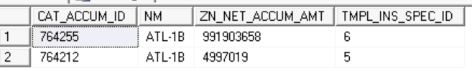
Summing of the value ‘ZN_NET_ACCUM_AMT’ is 996900677 this value will summed with the value of LocLoss in GetAccumulation result ‘4432.675’ and final value as ‘996,905,110’
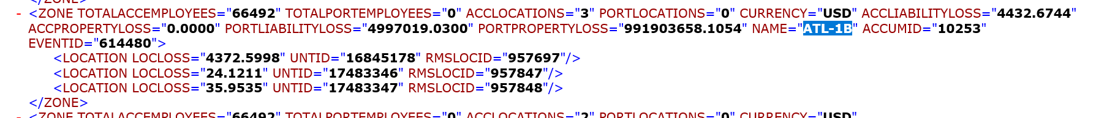
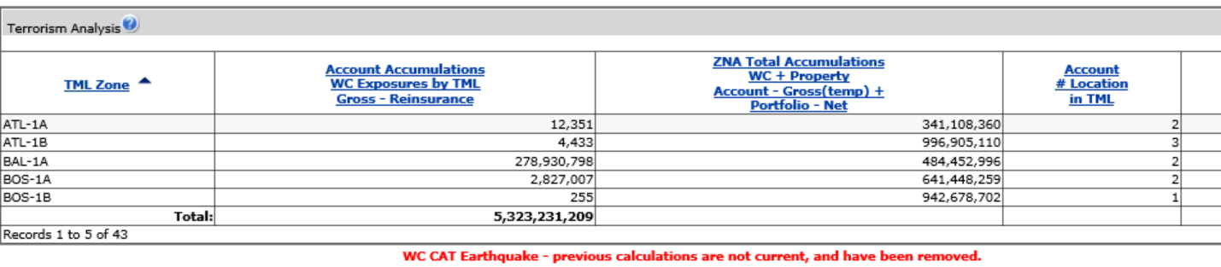
Account # Location in TML:
->Count of locations attached to specific TML Zone i.e. count of UNT_ID's (available in Get Accumulations Results) w.r.t TML Zone.
ZNA Total # Locations in TML:
-> Sum of ZN_LOC_CNT AMT when TMPL_INS_SPEC_ID = 5 and TMPL_INS_SPEC_ID = 6 in CAT_ACCUM table w.r.t TML Zone
Example:
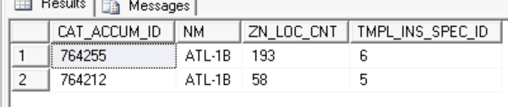
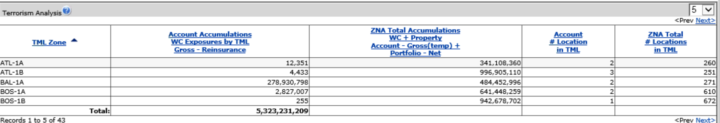

Analysis Details Screen:
Account Location Number:
This filed value is displayed from “UNDR_LOC_NBR” column from “SMSN_UNT” table . It is nothing but the location number given either in template(Column I in the location template) or given manually in field ‘Location Number’ in location tab in workbench.
Description:
This field value is displayed from “UNDG_NOTE” column from “LOC” table .It is nothing but the Description given either in template(Column Q in the location template) or given manually in field ‘Decscription’ in location tab in workbench
Address:
This field value is displayed from “ADDR” column in “GEOG_LOC” table. It is nothing but address of the location given either in the Location template (Column K in the location template) or given manually in field ‘Street Address’ in location tab in Workbench.
City:
This field value is displayed from “CTY_NM” column in “GEOG_LOC” table . It is nothing but city of the location given either in the Location template(Column M in the location template) or given manually in field ‘City’ in location tab in workbench.
State:
This filed value is displayed from “ST_ABBR” column in “GEOG_LOC” table . It is nothing but state of the location given either in the Location template(Column N in the location template) or given manually in field ‘State’ in location tab in workbench.
Postal Code:
This field value is displayed from “ZIP_CD” column in “GEOG_LOC” table . It is nothing but zip code of the location given either in the Location template(Column O in the location template) or given manually in field ‘Postal Code’ in location tab in workbench.

Match Level:
This field value is displayed from “GEO_MLVL_DESC_TXT” column in “RMS_GEO_MLVL_DESC_LKUP” table . The “RMS_GEO_MLVL_DESC_LKUP_ID” column value of “GEOG_LOC” table is mapped with RMS_GEO_MLVL_DESC_LKUP_ID of “RMS_GEO_MLVL_DESC_LKUP” table based on which “GEO_MLVL_DESC_TXT” is fetched.
Total Employees:
This field value is displayed from “EMPE_CNT_NBR” column in “LOC” table . It is nothing but Total Nbr of Employees at Location given either in the Location template(Column R in the location template) or given manually in field ‘Total Employees’ in location tab in workbench.
Max Employees:
This field value is displayed from “MAX_EMPE_CNT_NBR” column in “LOC” table . It is nothing but Max Nbr of Employees at any given time either in the Location template(Column S in the location template) or given manually in field ‘Maximum Employees’ in location tab in workbench.
TML Zone:
This field value is displayed from ‘NM’ column in “CAT_PRL_ZN” table . The Event ID which is received from Get Accumulations results is used to retrieve the TML Zone.
->Event ID will be mapped to OT_PRL_ZN_ID column in table CAT_PRL_ZN_XREF
-> Based on OT_PRL_ZN_ID, CAT_PRL_ZN_ID will be retrieved
-> Based on the CAT_PRL_ZN_ID, TML Name will be retrieved from the column 'NM' from table CAT_PRL_ZN
Account Location WC Exposure Contribution to TML Gross-Reinsurance:
This field value is displayed from “LOC_CNTR” in “WC_CAT_TR_CPCTY_RSLT” table.This is nothing but the value ‘LOCLOSS' of each individual unit id .
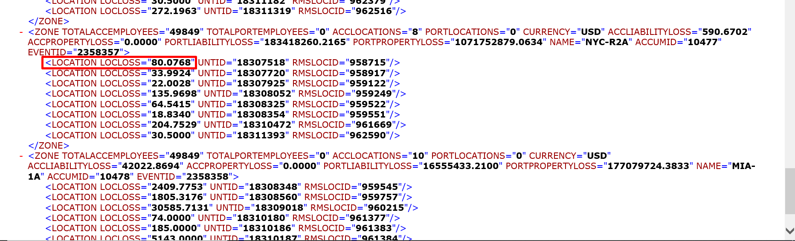
Account Location WC Exposure Total Exposure (is target) Gross-Reinsurance:
This value is calculated based on Construction code, Number of employees , State,Maximum number of employees, Percent of Employees Subject to Longshore Act ,Year Built, Excess Comp Policy, Building height.
Default values are mentioned below in case if the above values are not passed through location template or manually
Construction class code default value is “0”
Building height default value is 1
Built in year default value is “1969”
Maximum number of employees default value is 0
Number of employees default value is 0
Excess Comp Policy default value is “N”
Percent of Employees Subject to Longshore Act default value is 0
Building age is calculated by subtracting Built in year from Latest date
Based on the construction class code ,Building height, Building age score will be calculated . The logic for calculating score is as follows. Initially score value will be zero
- If the build height is greater or equal to 4 and less than or equal to 14 we will be adding +2 for the score
- If the building height is greater than or equal to 15 we will be adding +4 for the score
For example if our building height is 50 which is greater than 15 then our score will be 4 . In case if building height is less than 10 which is less than 14 our score will be 2.
- Based on the building age which is calculated as mentioned above we will again increment or decrement the existing score. If building age is less than or equal to 10 we will decrement the score by 1 . In case if building age is greater than or equal to 50 we will increment the score by 1.
For example if our building height is 50 and building age is 100 then our score will become as 4+1=5
- Based on construction class code the above the above calculated score is again modified. The following are the conditions

- If Construction class code is “0” then no change in score
- If construction class code is “1” then +4 is added to score
- If construction class code is “3” then +2 is added to score
- If construction class code is “4” then no change in score
- If construction class code is “5” then -2 is added to score
- If construction class code is “6” then -2 is added to score
- If construction class code is “9” then +1 is added to score
- If construction class code is “10” then -1 is added to score

For example let consider above example where our score is 5 now let us assume if our construction class code is “6” then our score will become as 5-2=3

- Then after calculating score the next step is to calculate employee count for exposure. In case if maximum employees are not mentioned then the employee count for exposure is calculated as 0.85*number of employees .If maximum employees mentioned is greater than 1 then employee count for exposure value is equal to maximum number of employees

- If Excess Comp Policy is selected as ‘Y’ then we will check for the count of records “WC_EXPO_ST” by passing State and effective date if count returned is greater than zero then we will not change Excess Comp Policy value. In case if count is equal to zero we will change the value of Excess Comp Policy to ‘N’
- If Percent of Employees Subject to Longshore Act value is greater than zero then we will calculate Longshore value by passing State value as “LS”, Excess Comp Policy value as “N”, Longshore status as “Y” .
- If Percent of Employees Subject to Longshore Act value is zero then we will calculate Non longshore value by passing State, Excess Comp Policy , Long shore status as “N” .
- State , Excess Comp Policy, Long shore status ,Score are used for calculating average loss per employee. Based on the score the factor rate value will be fetched from “WC_EXPO_MOD_FCTR” table and based upon the state Exposure amount will be fetched from “WC_EXPO_ST” . Average loss per employee is calculate as sum of factorrate*Exposureamount

In this example shown below the Maximum number of employees are not mentioned, Number of employees are 8,
Excess Comp Policy is ‘N’, Score is 5 , State is ‘NY’, Longshore status ‘N’
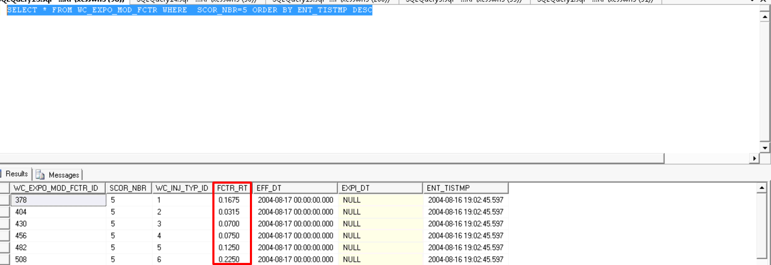
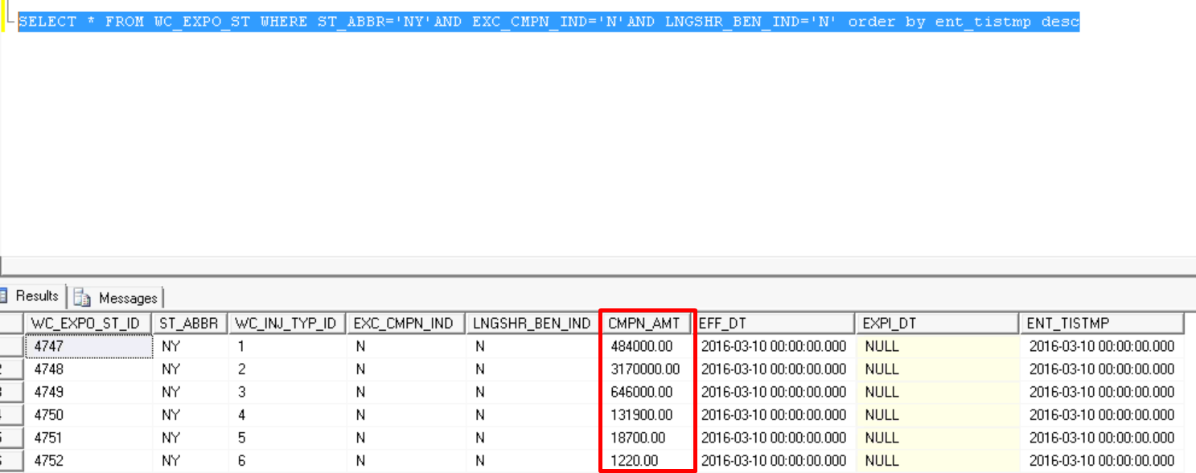

So the average loss per employee value is calculated as

(484000.00* 0.1675)+( 3170000.00* 0.0315)+( 646000.00* 0.0700)+( 131900.00* 0.1250)+( 18700.00* 0.2250)+( 1220.00* 0.3060)= 238649.50000000
- The Non long shore value = (1- Percent of Employees Subject to Longshore Act)*Average loss per employee
= (1-0)* 238649.50000000
=238649.50000000

- The Account Location WC Exposure Total Exposure (is target) Gross-Reinsurance value is calculated
as (nonlongshorevalue + longshorevalue)* employee count for exposure

=(238649.50000000+0)*6
=1431897.00000000

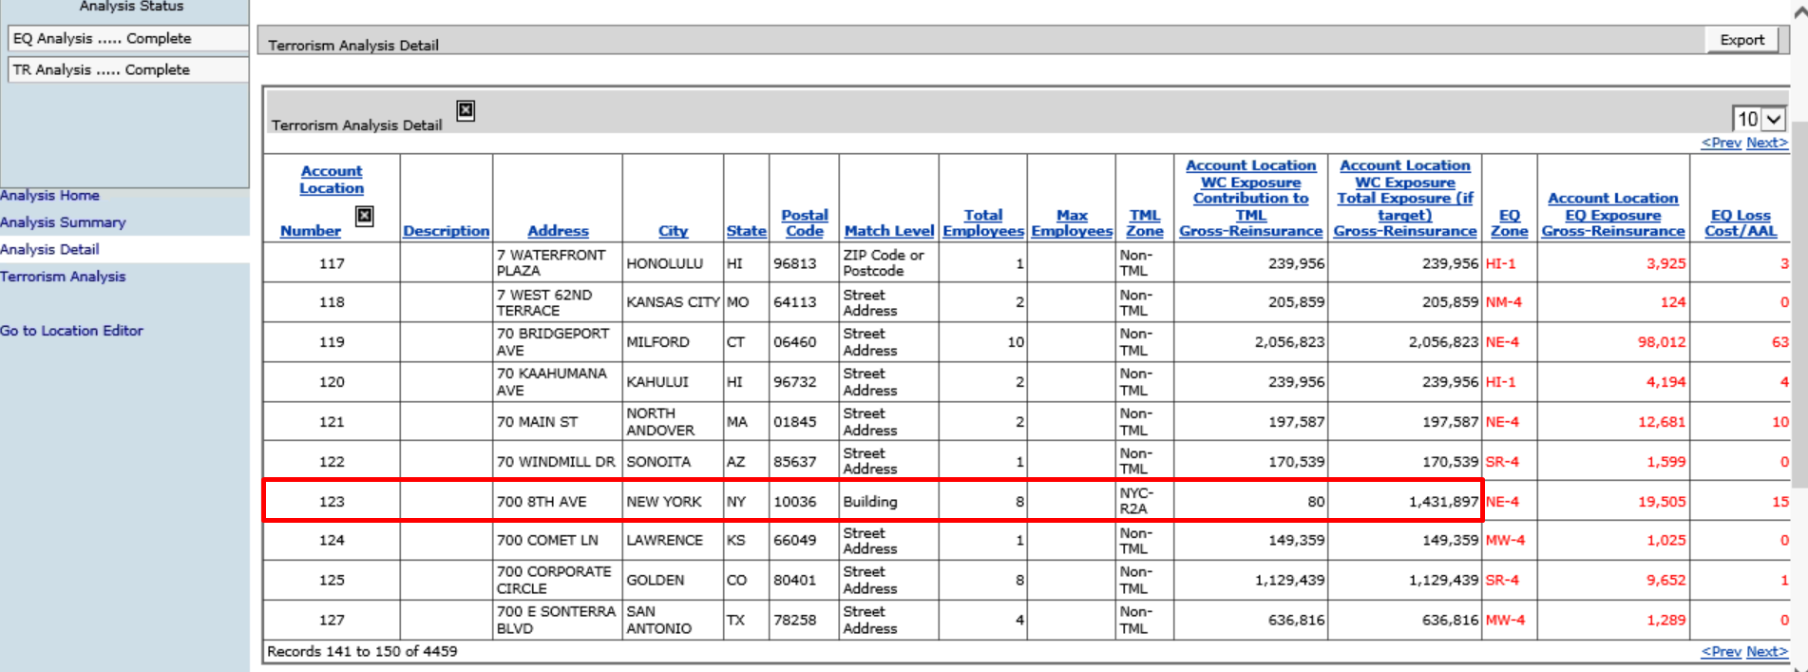

Note : This document consists of calculations related to WC cat analysis functionality except few fields in Analysis detail screen which we are analysing and provide ASAP.

